DEAFBLIND SERVICES **NEED STABLE** IN OHIO

Columbus Speech & Hearing LogoPILOT

PROGRAM IMPACT. DEAFBLIND SERVICES **STILL NEEDED** IN OHIO.

**33 DeafBlind adults served by CSH. Ohio Residents with Dual Sensory Impairment (DSI)* = 84,797**

**With Pilot Program funding of $100K a year**

**33+**

DeafBlind adults served by CSH

Ohio Residents with Dual Sensory Impairment (DSI)*:

**84,797**

Columbus Speech & Hearing’s (CSH) statewide Support Service Provider Pilot Program is **serving DeafBlind adults around four major cities in Ohio, maintaining independent living and supporting basic quality of life.**

Trained SSPs provide mobility guiding, visual or audio information, and communication assistance for persons with deafblindness.

The Support Service Provider (SSP) Program is serving 30+ DeafBlind adults. We continue to receive service applications from DB across Ohio. **However, this vulnerable population needs stable funding. Please help us find a solution for services!**

**WITHOUT MY SSP … I cannot have access and guiding to:environmental/social surroundings; identify and interact with people; basic tasks: i.e., clothing and grocery shopping, reading mail, paying bills, banking, scheduling doctor visits; make informed, autonomous choices; attend religious and social activities; develop trust with a consistent provider, • complete forms for services, • know danger and safety issues,**

**WITHOUT MY SSP**

I cannot have access and guiding to:

* environmental/social surroundings
* identify and interact with people
* basic tasks: i.e., clothing and grocery shopping, reading mail, paying bills, banking, scheduling doctor visits
* make informed, autonomous choices
* attend religious and social activities
* develop trust with a consistent provider
* complete forms for services
* know danger and safety issues

**Unique Service Needs and Communication Modes Among DB\*\***

61% Speech Users

45% Visual + Tactile ASL. greater than

>100% due to DB who use both communication modes

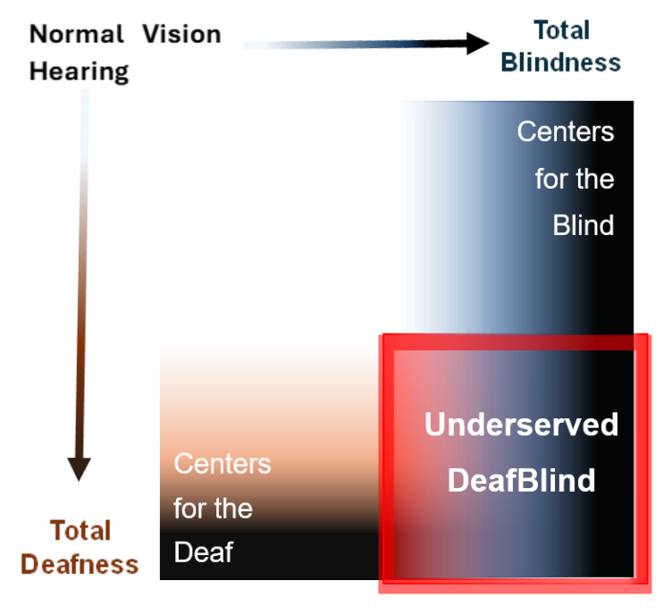A graphic displaying the spectrums of deafness and blindness and the underserved population of those with combined vision and hearing loss. Vision loss is shown along the top of the graphic. At the top left, Normal Vision moves to the right through progressively more severe vision loss to total blindness. The Centers for the Blind serve those experiencing vision loss. Hearing loss is shown along the left side of the graphic. At the top left, Normal Hearing moves down through progressively more severe hearing loss to total deafness. The Centers for the Deaf serve those experiencing hearing loss. At the bottom right corner, the intersection of vision and hearing loss shows the critically underserved DeafBlind population.

**Who will serve the DeafBlind?**

Deafblindness is a spectrum of dual sensory impairment. Those with deafblindness are a critically underserved population. Services must be tailored based on unique combinations of vision and hearing loss.

*Conway, M. & Brown-Ogilvie, T. (2024) Individuals with Combined Hearing and Vision Loss: Data from the American Community Survey. Helen Keller National Center for DeafBlind Youth and Adults.

**Brown-Ogilvie, T., Alleman, J., & Conway, M. (2024). Recognizing the Needs of Older Adults with Combined Vision and Hearing Loss. [Research to Practice Paper]. Helen Keller National Center for DeafBlind Youths and Adults.

**The Community Supports SSP Services**

A non-profit serving Ohio since 1923. The Community Supports SSP Services

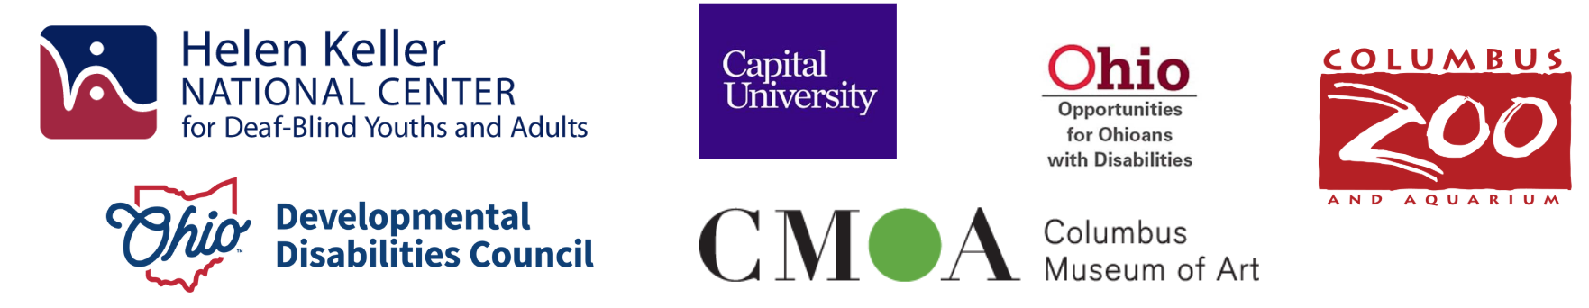

**Columbus Speech & Hearing is grateful to recognize strong partners and support for our work.**

**Helen Keller National Center for Deaf-Blind Youths and Adults Logo, Capital University Logo, Opportunities for Ohioans with Disabilities Logo, Columbus Zoo and Aquarium Logo, Ohio Developmental Disabilities Council Logo, Columbus Museum of Art Logo**

**List of additional strong community partners: Ohio Deaf and Blind Education Services; The Ohio Center for DeafBlind Education: University of Cincinnati; Speech & Hearing Centers throughout Ohio; Ohio Association of the DeafBlind; Clovernook Center for the Blind and Visually Impaired;**

**Columbus State Community College; Kent State University; Ohio Deaf Association; I Can Connect (ICC); Center of Science and Industry (COSI); Ohio Deaf Friends of the Library; Disability Rights Ohio; Sinclair Community College; Columbus Colony Housing; Columbus Colony Elder Care Nursing Home; Ohio Center for Autism & Low Incidence (OCALI); Spring Grove Cemetery and Arboretum;**

**Ohio Deaf Friends of the Library; Good Sign Coffee; Art Possible; National Federation of the Blind;**

**Community Centers for the Deaf throughout Ohio**

Ohio Deaf and Blind Education Services

The Ohio Center for DeafBlind Education: University of Cincinnati

Speech & Hearing Centers throughout Ohio

Ohio Association of the DeafBlind

Clovernook Center for the Blind and Visually Impaired

Columbus State Community College

Kent State University

Ohio Deaf Association

I Can Connect (ICC)

Center of Science and Industry (COSI)

Ohio Deaf Friends of the Library

Disability Rights Ohio

Sinclair Community College

Columbus Colony Housing

Columbus Colony Elder Care Nursing Home

Ohio Center for Autism & Low Incidence (OCALI)

Spring Grove Cemetery and Arboretum

Ohio Deaf Friends of the Library

Good Sign Coffee

Art Possible

National Federation of the Blind

Community Centers for the Deaf throughout Ohio

Community collaborations include partnering to create events such as the **Columbus Zoo and Aquarium’s “Blind, Deaf, and DeafBlind Accessibility Day”** and the **Ohio Developmental Disabilities Council’s “My Life, My Story”** live presentations by DeafBlind individuals at the **Columbus Museum of Art**.

These partnerships are resulting in improved access, increased community awareness, and enhanced opportunities for advocacy.

**DeafBlind Population Increasing: Most become DB after aging out of school services. As the aging population continues to grow in Ohio and nationwide, we will see increases in age-related deafblindness. In fact, the largest population experiencing deafblindness are adults 55 and older.\***

**DeafBlind Population Increasing**

Most become DB after aging out of school services.

As the aging population continues to grow in Ohio and nationwide, we will see increases in age-related deafblindness. In fact, the largest population experiencing deafblindness are adults 55 and older.*

**Comments from the Community**

**“... I wish there was support for those of us DB who are alone. Can be hard to find trusted help. Can be scary.” \***

**“Ohio needs to fund the expanding demand of services for the DeafBlind.”**

**Although services for youth with a disability exist in Ohio, the schools that work closely with our DeafBlind population ‘wonder where their young adult graduates will access services.’**

**“Isolation impacts my physical and mental health. Without my SSP, I am completely isolated.”**